HUMAN RIGHTS COMMITTEE
94th Session (13-31 October 2008), Geneva

Japan:

Alternate report:

Submitted by Japan Fellowship of Reconciliation (JFOR),
a non-governmental organization in special consultative status with ECOSOC
--A way towards legislative solution:
the issue of “Comfort Women”, namely military sexual slavery by Japan—

Prepared by Dr. TOTSUKA, Etsuro
Main Geneva Representative to the UN of JFOR
Professor, Ryukoku University, Japan

JFOR welcomes the list of the issues sent to Japan by the HRC. and wishes to focus on its para. 21, which raised the issue of military sexual slavery by Japan.

The fifth Japanese government’s report (CCPR/C/JPN/5) does not report that Japan is now legally capable to settle the issue of “Comfort Women”, namely military sexual slavery by Japan through legislative measures by the National Diet of Japan, although this must be a matter of concerns of the HRC in relation to Articles 7 and 8 of the ICCPR. Many victims are passing away year by year and the time for Japan to start reconciliation is becoming shorter and shorter. The government of Japan regrettably seems to be waiting for the dying out of all victims.

1. The information on the issue of “comfort women” and the UN
The author representing International Educational Development (IED) made the first oral intervention before the UN Commission on Human Rights on 17 February 1992, in which Japan was condemned for its crimes against humanity onto the Korean and other Asian "sex slaves" (UN doc. E/CN.4/1992/SR.30/Add.1.).
This was followed by consistent and persistent activities made by more influential UN NGOs such as the International Commission of Jurists, the World Council of Churches, the International Fellowship of Reconciliation, the International Association of Democratic Lawyers, Liberation, World Alliance of Reformed Churches, Amnesty International and JFOR as well as many local civil groups outside of and inside Japan for 16 years. They attended nearly all of the UN human rights meetings, in particular the Working Group on Contemporary Forms of Slavery, the Sub-Commission on Promotion and Protection of Human Rights, and the Commission on Human Rights as well as Human Rights Council UPR. Thus, they succeeded in proving the capacity of the UN over the issue of “military sexual slavery” by Japan and secured some resolutions, reports, recommendations from the UN and ILO bodies against Japan.
Good evidence might make forces of persuasiveness, even if it was presented by only one person (Y. Yoshimi, Jugun ianhu shiryousyu, Otsuki shoten (1992).). Testimonies of the victims were well researched by Korean scholars (K. Howard (ed.), True stories of Korean comfort women, Cassell (1995).). Japanese historians' researches (Center for Research and Documentation on Japan's War Responsibility, The Report on the Issue of Japan's Military "Comfort Women" (1994)) were submitted to the UN WGCFS. Sound and well developed legal arguments could have also strong forces. A mission report by the International Commission of Jurists (U. Dolgopol & S. Paranjape, Comfort Women an Unfinished Ordeal (1994), ICJ. p. 205.) gave a strong impact to the UN and world public opinion. The International Fellowship of Reconciliation (IFOR) and the Japan Fellowship of Reconciliation (JFOR) submitted some new legal aspects in their written statements to the UN (UN Doc. E/CN.4./1993/NGO/36; E/CN.4./1994/NGO/19; E/CN.4./Sub.2/1994/NGO/30; E/CN.4./1995/NGO/37; E/CN.4./1995/NGO/40; & E/CN.4./Sub.2/2000/NGO/12; E/CN.4/Sub.2/2002/NGO/23; E/CN.4/Sub.2/2001/NGO/24; E/CN.4/Sub.2/2003/NGO/46; E/CN.4/Sub.2/2004/NGO/28; & E/CN.4/Sub.2/2005/NGO/35). The Japan Federation of Bar Associations clarified some vital legal issues including treaty defense of the Japanese government in their two legal opinions (Recommendations on the Issue of "Comfort Women" (January 1995) & Supplementary Explanation of the Recommendations on the Issue of "Comfort Women" (June 1995).). The Federation of Korean Trade Unions submitted a few communications including a detailed legal analysis ("Comfort Women" Military Sexual Slavery by Japan (1997).) concerning Japan's violations of the Forced Labour Convention to the ILO Committee of Experts.

2. The response made by Japan
The Japanese government led by then P.M. Mr. Ryutaro Hashimoto, who had been the top leader of the Japanese ex-soldier's bereaved family's association before he became Prime Minister, argued that the issue of reparation was settled by peace treaties and that the Government would never pay compensation to the victims. Other Japanese government’s leaders have been maintaining the same position.
The Asian Women Fund, a private fund created by the Japanese civilians being assisted by the Japanese government did not resolve the legal state responsibilities of Japan of this issue and finished its operation in March 2007. The government has been refusing to take any other policy than the AWF.
The Special Rapporteur on violence against women of the CHR, Ms. Radhika Coomaraswamy in her report (E/CN.4/1996/53/Add.1) rejected the Japanese government’ argument as regards the AWF policy.

3. Breaking the treaty defense
As for the JFOR’s argument against the Japanese government treaty defense prepared by this author was submitted by JFOR to the UN HRC UPR in February 2008. As it is available at the UN Website, it is omitted herewith.
The victims are still entitled to demand individual reparation against the Japanese government.

４．A way towards legislative solution
Firstly, the proposals made by the Diet Members of the opposition parties for a state apology by legislation of the Japanese National Diet for state payment were successfully submitted to the House of Councilors and proved that such legislation would not violate any international law or the Constitution. They have been, however, blocked by the conservative Diet Members supporting the government.
Being encouraged by the resolutions addressed to Japan for its state apologies to the victims made the legislatures of the USA, EU, the Netherlands and Canada in 2007, the same bill was submitted to the Diet on 12 June 2008. It was, however, was aborted at the end of the Diet Session because of non-cooperation from the ruling parties. No report was made by the government to the HRC on such Diet Members’ efforts.

There exists a way out towards legislative solution. It is the lack of political will in the government for apology to the victims that blocks the hope for the solution.

The translation of the Bill is attached at the end of this paper. All supporting groups of the victims in the victimized countries such as the ROK are welcoming this Bill. As a result, there is a strong hope that this issue is voluntarity settled by the National Diet of Japan.

Secondy, the legislative proposals submitted by the Diet Members of the opposition parties to the House of Representatives for state investigation of the sufferings during war time have been also blocked by the conservative Diet Members supporting the government.

The people in Japan chose the oppositions in the 2007 election of the House of Councilors and the people are to decide the policies of Japan in the next general election of the House of Representative.

JFOR requests the HRC to encourage not only the Government but also the National Diet as well as the people in Japan to work for the solution of this issue.
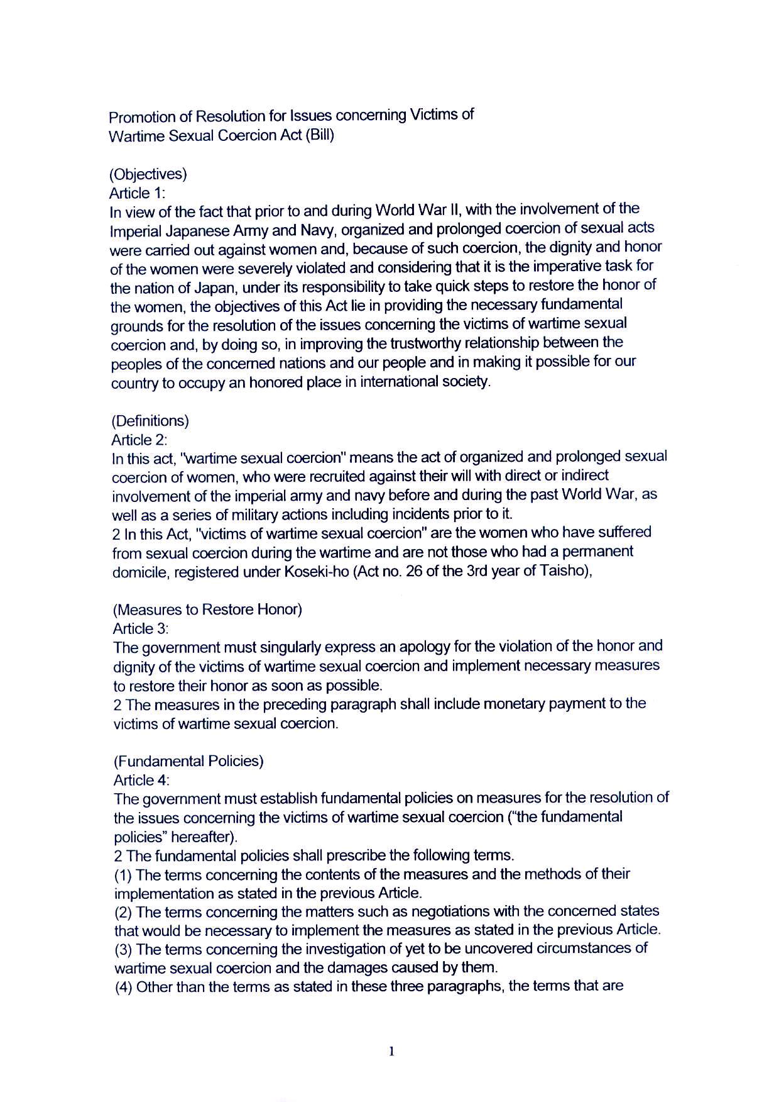

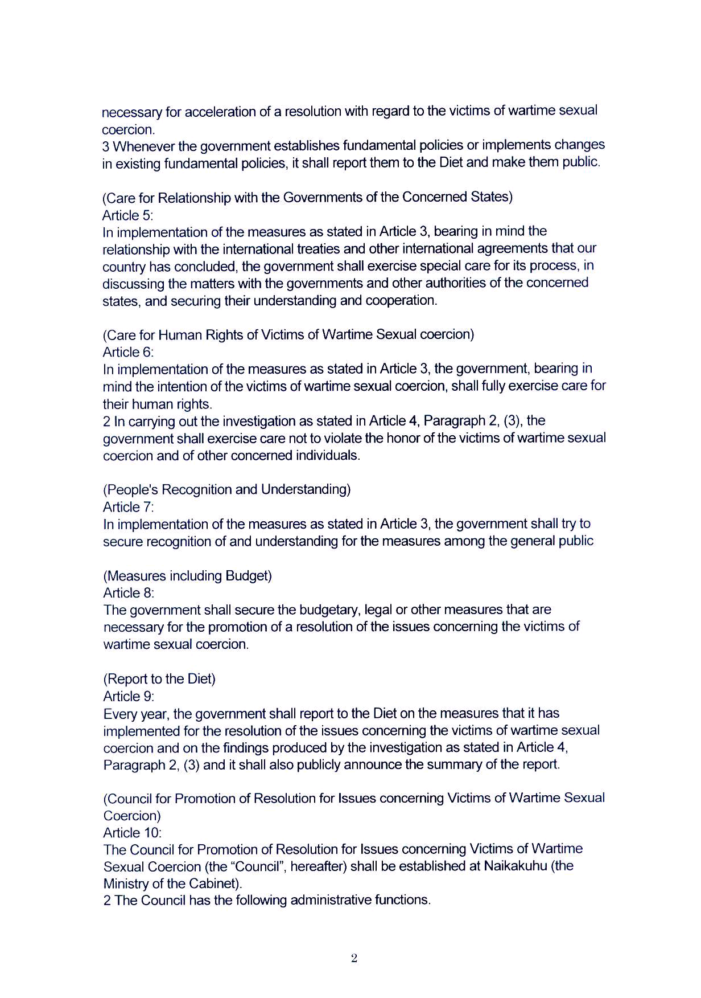

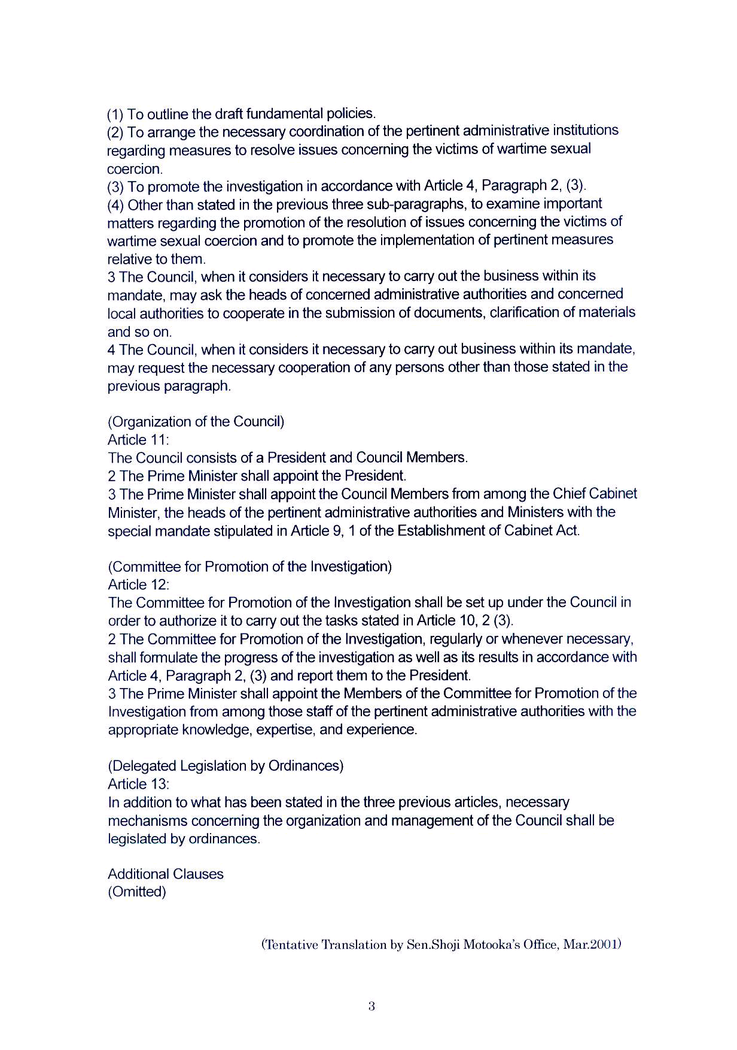

Geneva Main Representative to the UN, JFOR, Doctor of International Relations, Professor of Ryukoku University Law School. Home address: 27-17, Onohara Nishi-3 chome, Mino-shi, Osaka, Japan 562-0032. Tel./Fax. +81-(0)72 727 5551; E-mail: etsuro@poem.ocn.ne.jp.
Postwar responsibilities of Japan: “Comfort Women”, military sexual slavery ―― Non-fulfillment of obligations for apology, compensation, and punishment and the criticism of the treaty defense by Japan ――
UNOHCHR Website: Visited on 30 August 2008 at: http://lib.ohchr.org/HRBodies/UPR/Documents/Session2/JP/JFOR_JPN_UPR_S2_2008_JapanFellowshipofReconciliation_uprsubmission.pdf
The author, on behalf of Japan Fellowship of Reconciliation, has been reporting to the UN on the slow but steady development of the legislative movement as follows. In 2001: See: E/CN.4/Sub.2/2001/NGO/24, 24 July 2001, Written statement submitted by Japan Fellowship of Reconciliation (JFOR), a non-governmental organization in consultative status (Special)“Comfort women”: Current negative reactions and positive developments, to Sub-Commission on the Promotion and Protection of Human Rights, Fifty-third session, which stated “Three opposition parties succeeded, for the first time, in submitting to the House of Councilors a united Bill for “Promotion of Resolution for Issues concerning Victims of Wartime Sexual Coercion Act” below.” In 2002: See: E/CN.4/Sub.2/2002/NGO/23, 25 July 2002, Written statement submitted by Japan Fellowship of Reconciliation, a non-governmental organization in special consultative status to Sub-Commission on the Promotion and Protection of Human Rights, Fifty-fourth session, which stated “For the first time in history, on 18 July 2002, the Committee on Cabinet Affaires of the House of Councilors of the Diet of Japan started its substantial deliberation on a Bill, “Promotion of Resolution for Issues concerning Victims of Wartime Sexual Coercion Act”.” In 2003: See: E/CN.4/Sub.2/2003/NGO/46, 30 July 2003, Written statement submitted by Japan Fellowship of Reconciliation, non-governmental organizations in special consultative status "Comfort Women": Systematic rape, sexual slavery and slavery-like practices, to the Sub-Commission on the Promotion and Protection of Human Rights, Fifty-fifth session, which stated “Members of the House of Councilors of the Japanese National Diet, Ms. OKAZAKI, Tomiko; Ms. MADOKA, Yoriko; Ms. CHIBA, Keiko; Ms. KAWAHASHI, Yukiko; Ms. YOSHIKAWA, Haruko; Ms. HATTA, Hiroko; Mr. YOSHIOKA, Yoshinori; Ms. OWAKI; Masako; Ms. FUKUSHIMA, Mizuho; Mr. KUROIWA Takahiro; Mr. SHIMABUKURO Soko; Ms. TAJIMA, Yoko; and Ms. TAKAHASHI, Kiseko with support of other 73 Members of the House, on 31 January 2003, re-introduced a Bill, "Promotion of Resolution for Issues concerning Victims of Wartime Sexual Coersion Act" to the House at the 2003 Ordinary Diet Session. The Bill is the same as the previous bill See: E/CN.4/Sub.2/2001/NGO/24 and E/CN.4/Sub.2/2002/NGO/23, which was abolished at the end of the last Diet session in December 2002. …The National Diet of the Republic of Korea, a major victimized nation, made the following significant resolution that guaranteed success of the Bill mentioned above on 26 February 2003 at the opening of President ROH Moo-hyn's Era.”
The information of the movement to actualize the legislation for the fact-finding is available in Japanese at the following web site of “Senso-Higai-Chosakai-Ho wo Jitsugensuru Shimin-Kaigi”, hit on 10 February 2004. http://www.geocities.co.jp/HeartLand-Keyaki/5481.

